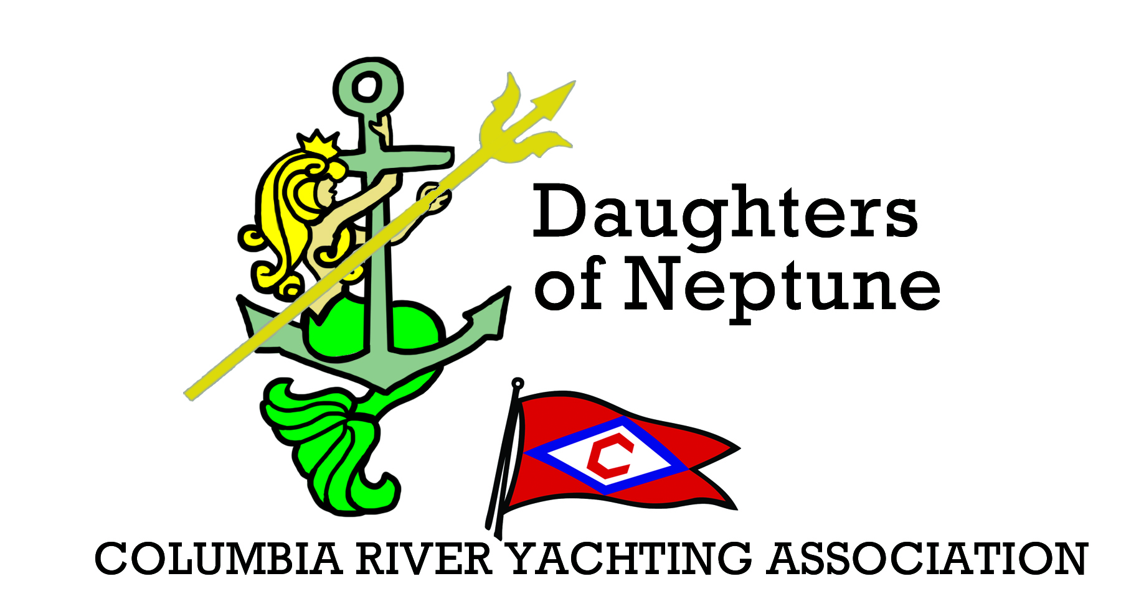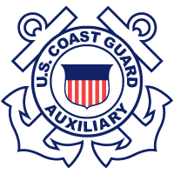

BOATER’S EDUCATION CLASS

Card REQUIRED to operate any vessel over 10hp

SUNDAY, FEBRUARY 23rd
8:30am – 5:30pm
At Tyee Yacht Club

Cost is $16 CASH for light breakfast, lunch,and class
Additional $10 is due to state upon completeling class for permanent card (more information at class)
Must have at least 10 students to hold class

PLEASE CONTACT VICKI JUSTICE AT
Vicki-don@crya.us
For more information and to sign up!!

